
Koneru Lakshmaiah Education Foundation
(Deemed to be University estd. u/s. 3 of the UGC Act, 1956)
Off-Campus: Bachupally-Gandimaisamma Road, Bowrampet, Hyderabad, Telangana - 500 043. Phone No: 7815926816, www.klh.edu.in

STUDENT CASE STUDY EXECUTION REPORT
Department | FED
Subject | DSA-2
Academic Year | 1-111 Semester | 2025-26
Faculty Name | Ms. P.Surekha
Student Name | M.Sreeya
Roll Number | 2500032243
Branch | CSE
Course Outcome | 12SC1305E
Case Study Topic Cyber Attack Path Analysis System
Work Done Summary:
In this case study, I implemented a Graph–based cyber attack path analysis system for efficient network traversal and attack route detection.
The graph structure was used to represent interconnected network systems, while BFS, DFS, and Dijkstra algorithms were used to analyze cyber attack propagation across different network paths. I analyzed multiple compromised network nodes and identified possible attack routes leading to critical systems.
I also implemented shortest attack path detection, network traversal analysis, and attack route monitoring to improve real-time cybersecurity investigation efficiency.
Implementation Details:

1. Represented network systems and connections using Graph data structures.

2. Implemented BFS traversal for attack propagation monitoring.
3. Implemented DFS traversal for deep network investigation.
4. Applied Dijkstra Algorithm for shortest attack path detection.

5. Analyzed compromised network nodes and vulnerable routes.

6. Implemented attack route monitoring and cybersecurity alert generation.
7. Concluded Graph algorithms are efficient for scalable cyber attack path analysis because traversal and shortest path operations improve network investigation efficiency.

Result: Screenshots / Output
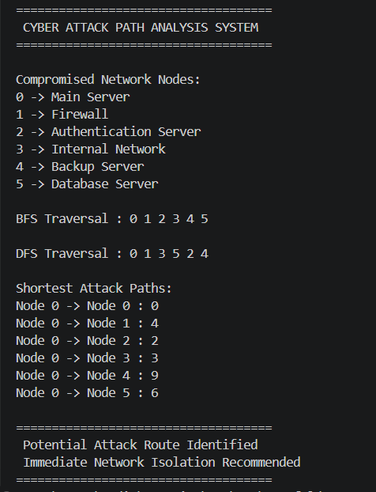
The cyber attack path analysis system successfully analyzed compromised network connections using Graph traversal algorithms.
The system efficiently monitored attack propagation paths, identified vulnerable network routes, and detected shortest attack paths leading to critical systems.
BFS, DFS, and Dijkstra algorithms improved network investigation efficiency, making the framework suitable for scalable real-time cybersecurity attack path analysis applications.
Time Complexity:
• BFS Traversal : O(V + E)
• DFS Traversal : O(V + E)
• Dijkstra Algorithm : O((V + E) log V)

GitHub Link: https://github.com/medipallysreeya-commits/Adaptive-Cyber-Threat-Indexing-Framework.git
Student Signature | Faculty Signature

